**Week9**

**PORTFOLIO**

**Assessment Weightage & Type:**

**60% Portfolio Coursework**

**Year:2024**

* Student Name: Pratha Sharma
* UWE ID: 24030176
* Module code: **UFCFL1-15-0**
* Level: **Level 3)**
* Faculty: **Faculty of Internet & Technology**
* Department: **FET Department of Computer Science & Creative**

**Technology**

**Week 9**

**Task 1 -**

Reproduce the following table using CSS positioning (relative or absolute) instead of <table>.

Code:

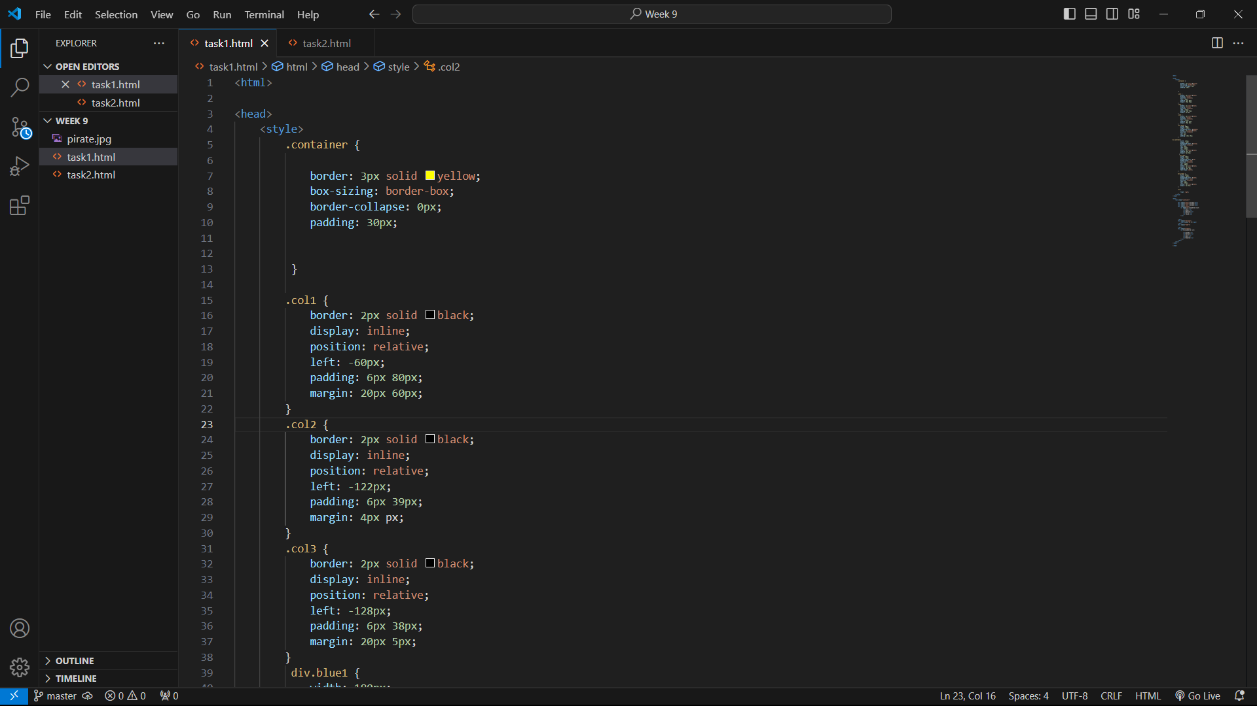

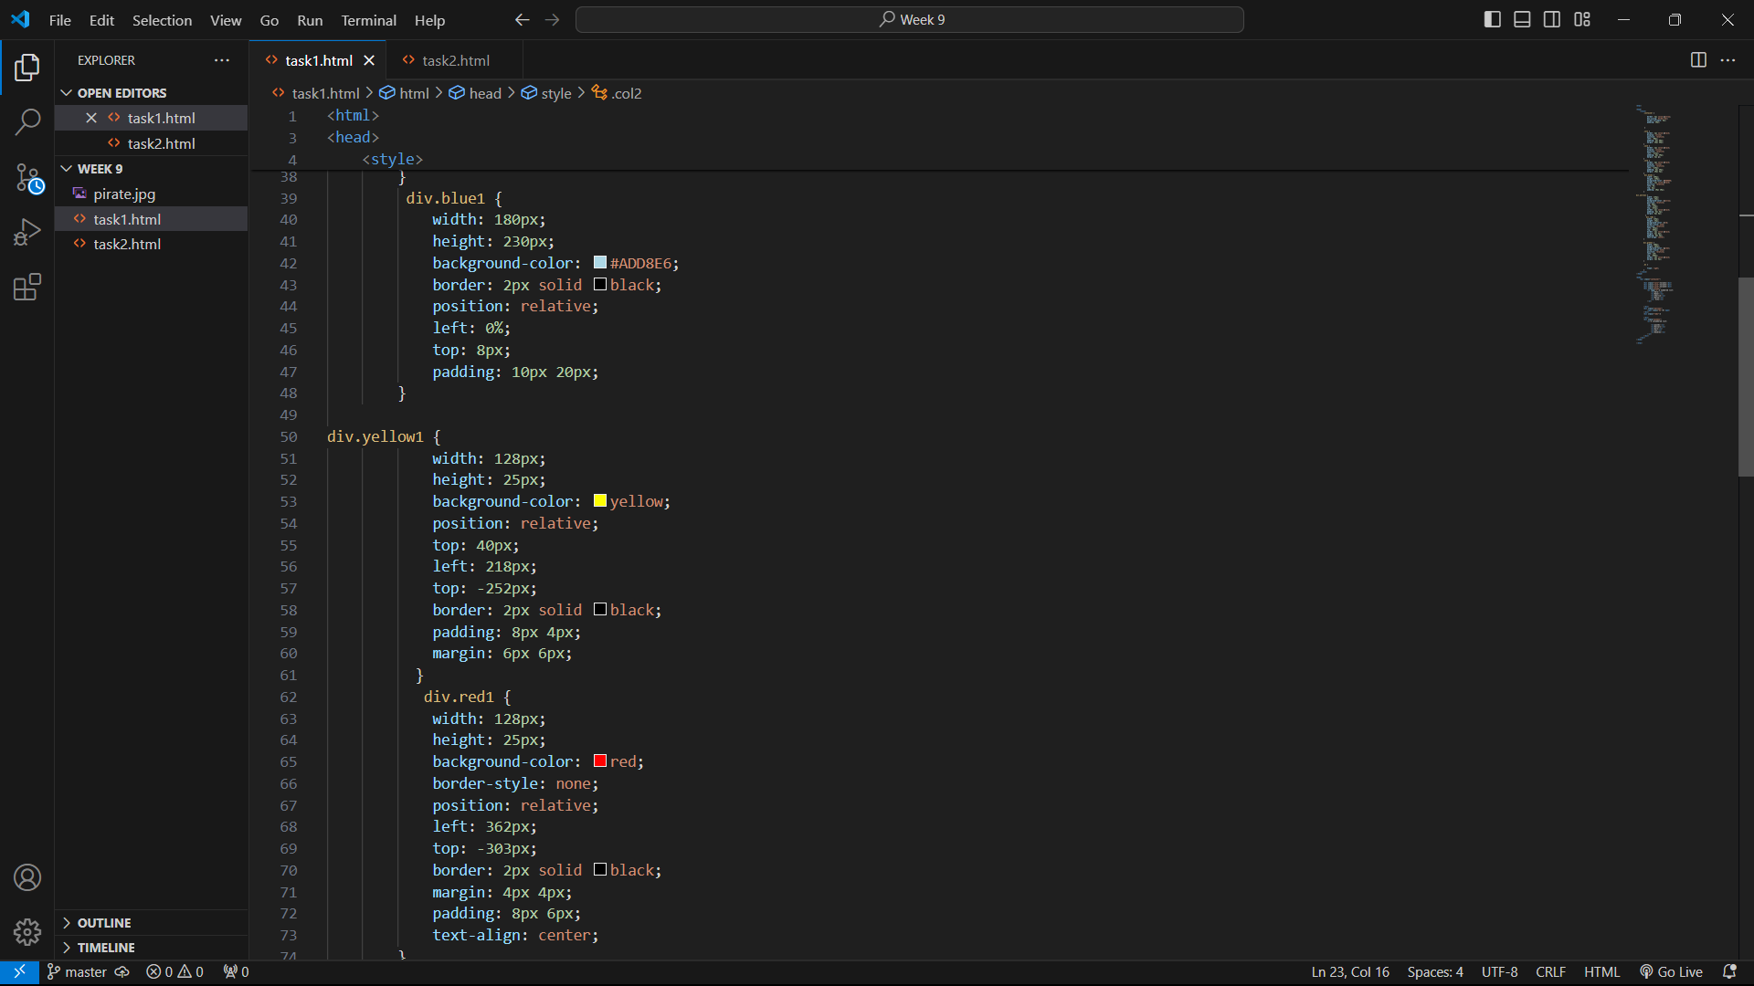

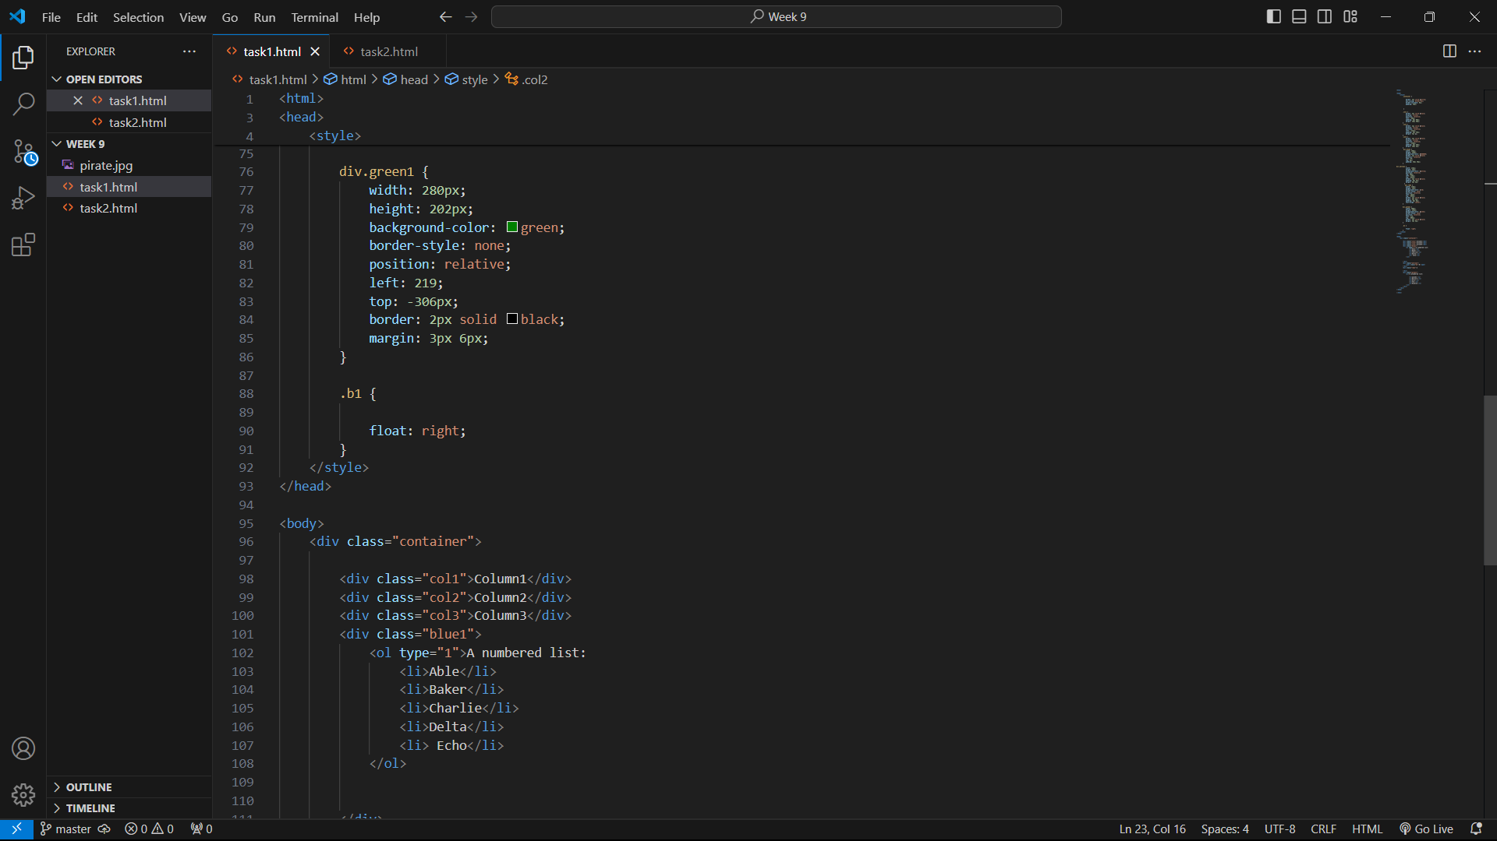

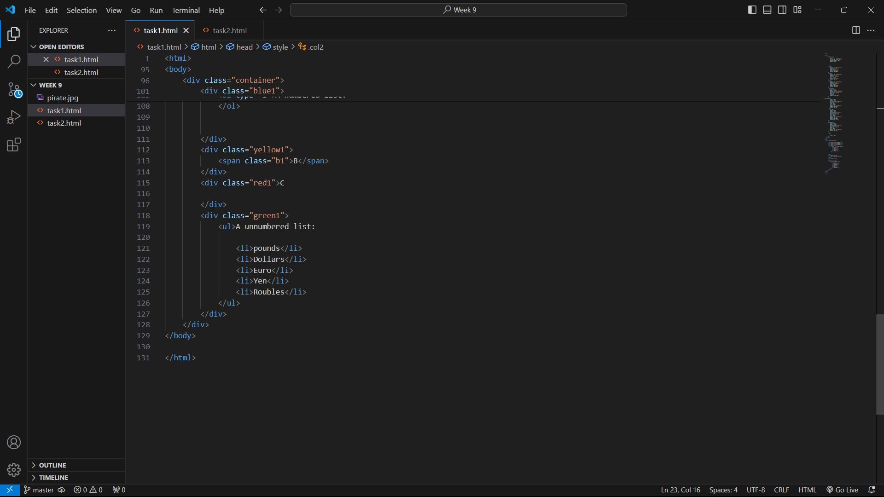

Website:

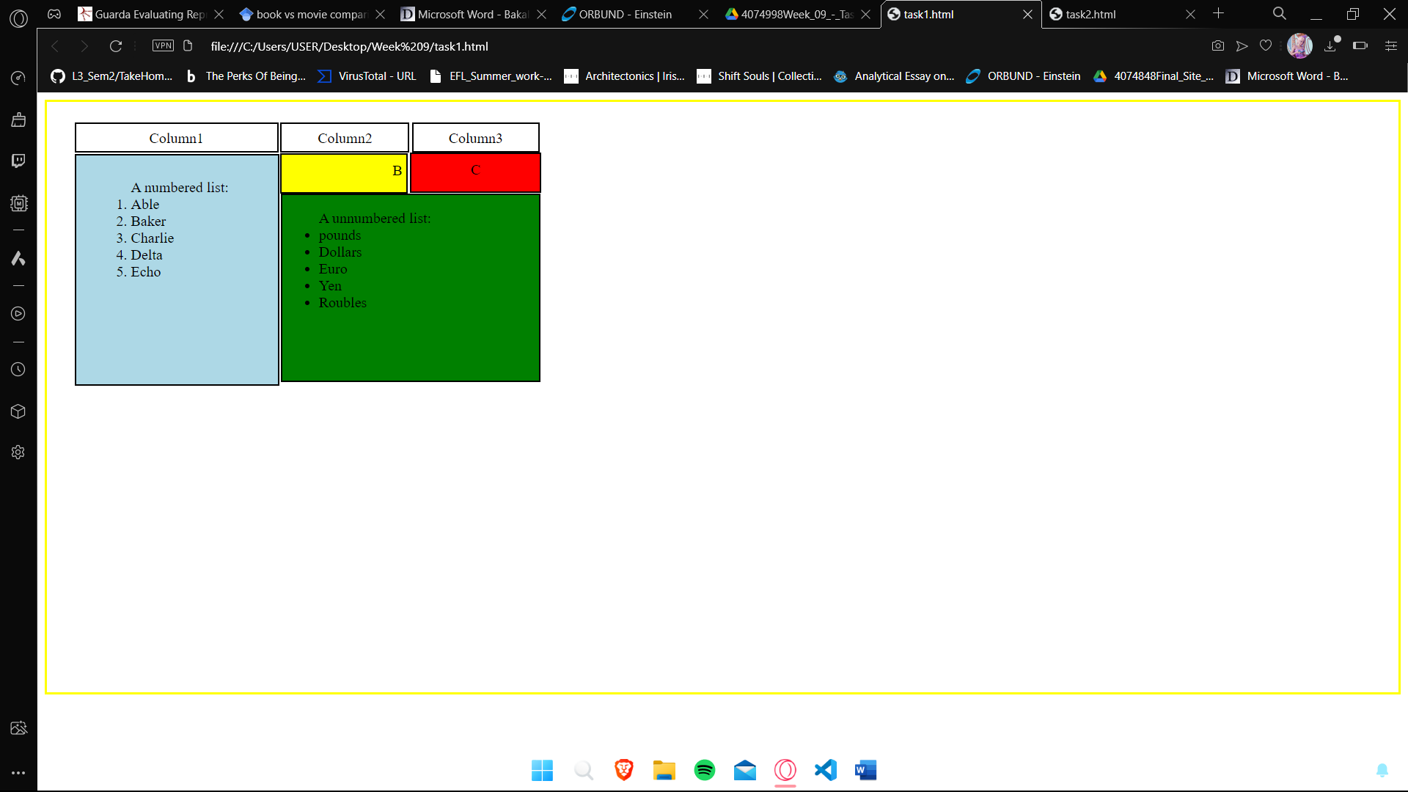

**Task 2 -**

Write the appropriate CSS to change the presentation of the webpage to that shown in figure below. The new page

layout includes a header section, two columns (one for navigation menu and one for the main content) and a footer

section.

Code:

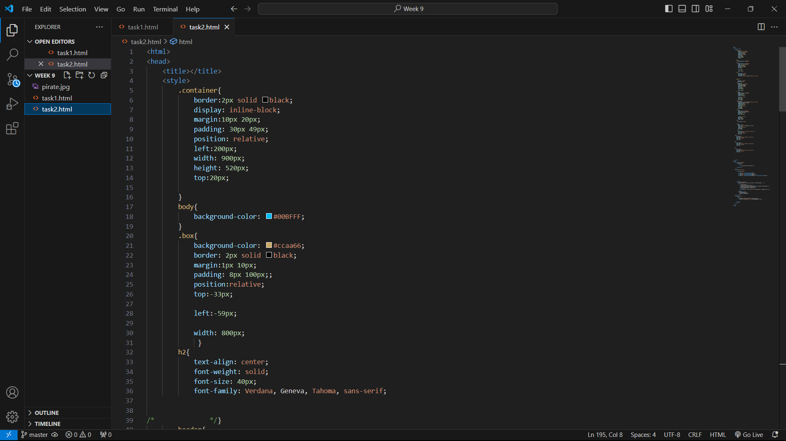

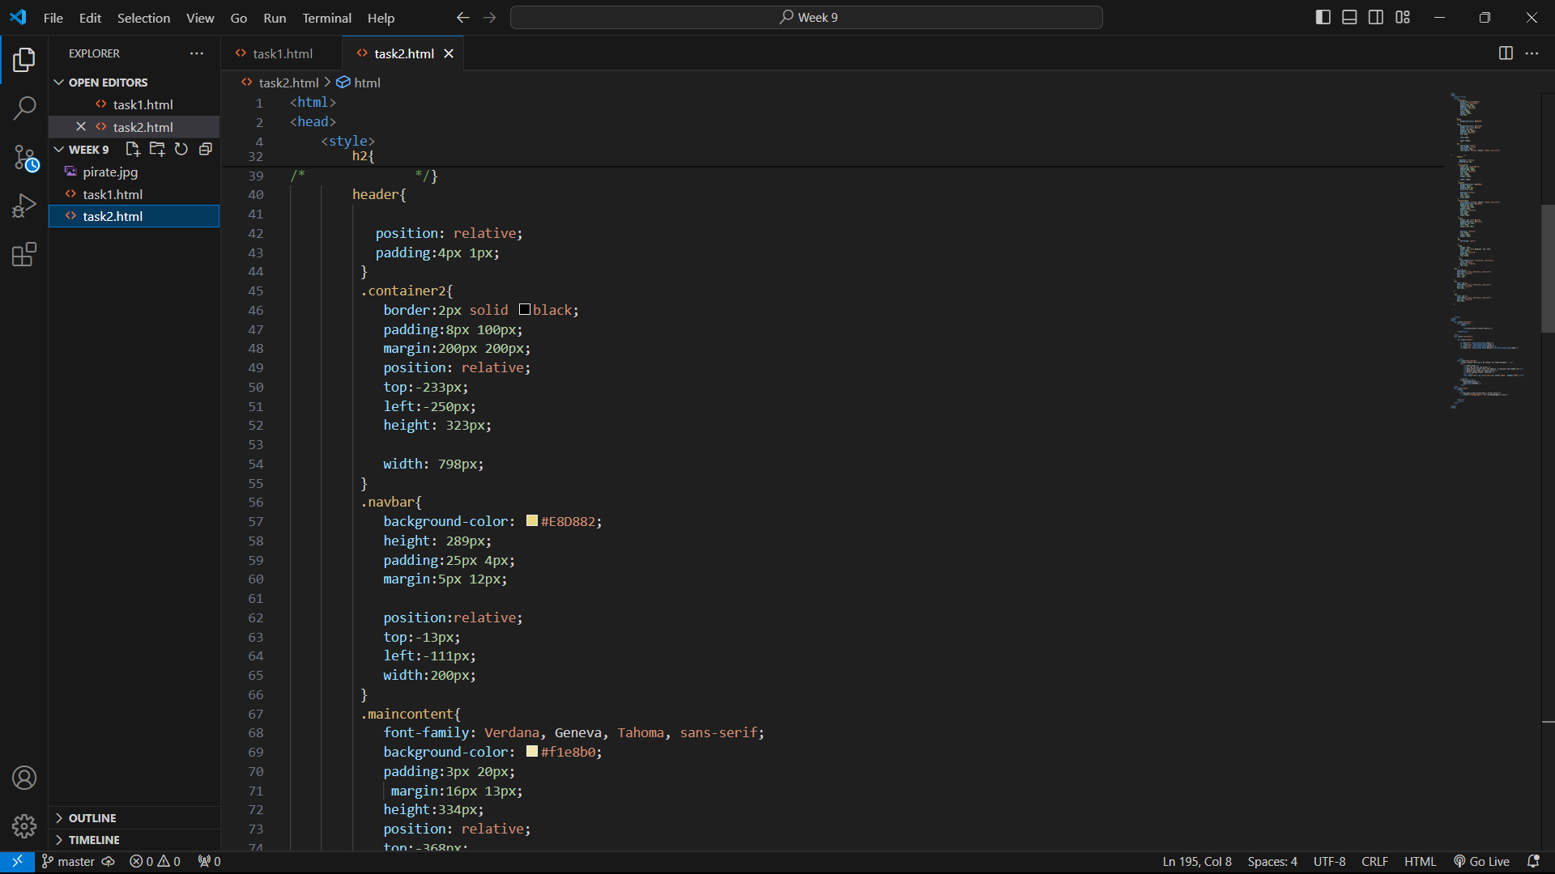

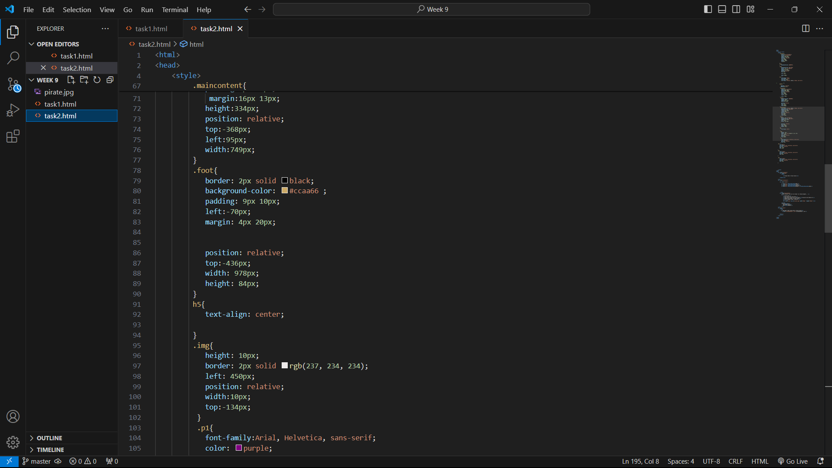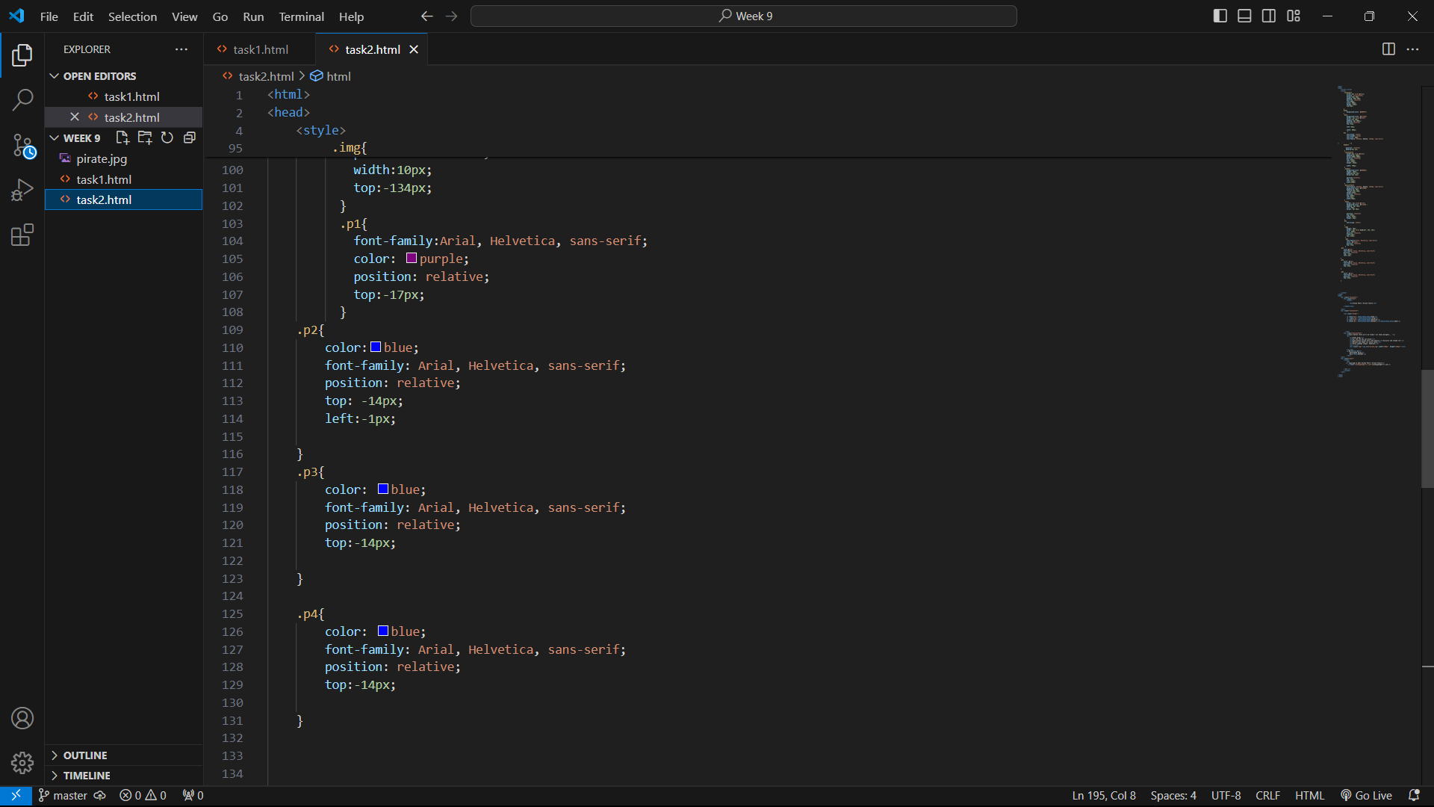

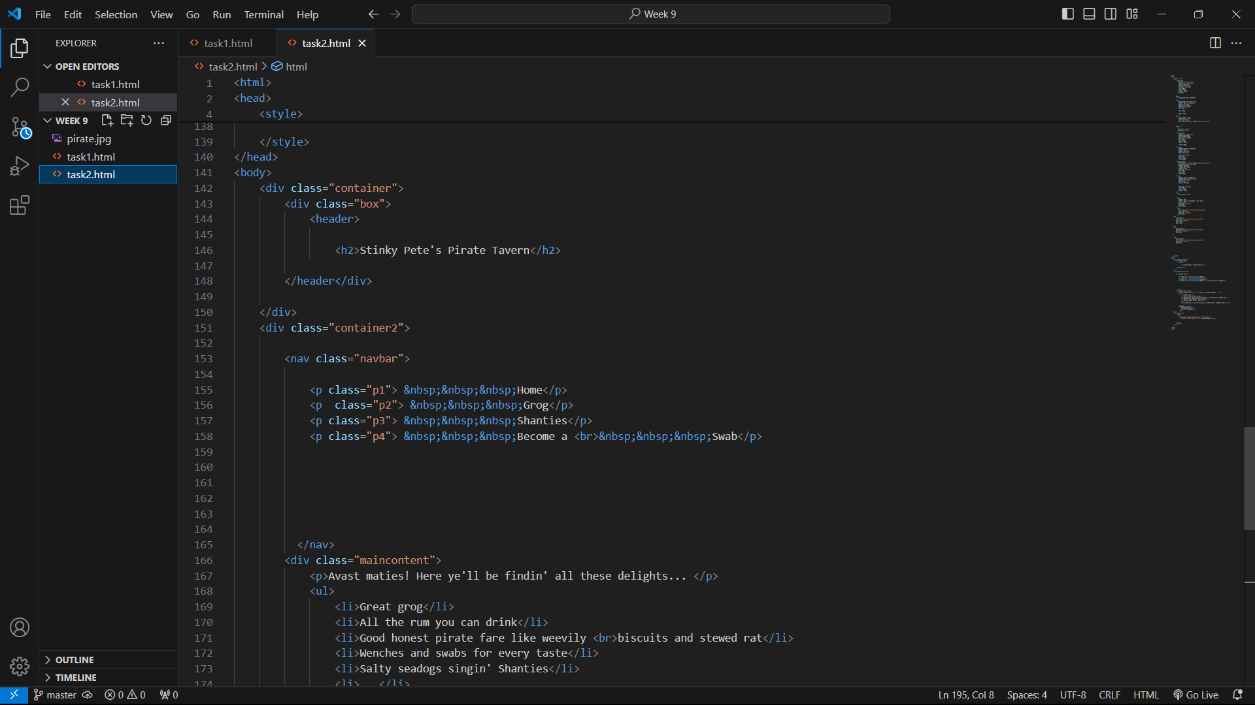

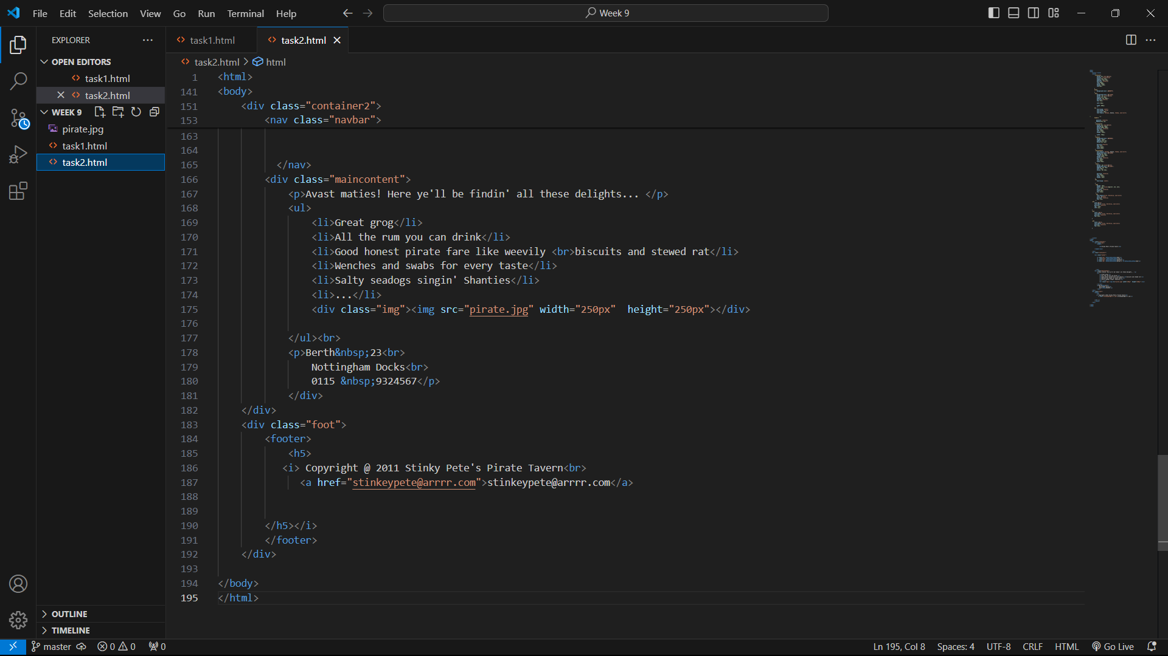

Website:

